

**Polling District and Polling Place Review 2025**

**Lemington Ward**

**Parliamentary Constituency:** Central and West

**(Proposed) Polling Districts:** P01, P02, P03, P04, P05, P06

The Local Government Boundary Commission for England are an independent body accountable to Parliament. They are responsible for reviewing councils to make sure their patterns of internal wards are fair and sensible. Their reviews include at least two rounds of public consultation before they make recommendations for change.

The final recommendations were published on 7 January 2025, and the new arrangements apply to local elections from 2026.

As a result of changes to ward boundaries the Acting Returning Officer (ARO) is conducting a review of polling districts and polling places to ensure that they are suitable for the new ward boundaries.

For more information on the local government boundary review visit: <https://www.lgbce.org.uk/all-reviews/newcastle-upon-tyne>

This document provides details of the review, along with the initial recommendations and comments of the Acting Returning Officer (ARO). Also, the election rules require the ARO to decide how many polling stations are required for each polling station and the ARO must allocate electors to the polling stations in such manner as they think most convenient.

These recommendations will be open to all residents, stakeholders, and any interested parties. We shall be seeking representations from local disability groups on the accessibility and suitability of polling places. Any comments should be addressed in the first instance to pollingplaces@newcastle.gov.uk where they will be collated on behalf of the (Acting) Returning Officer.

We considered the following factors:

* **Identifying new polling places:** We will look for new polling places in areas where the existing provision is unsuitable or unavailable.
* **Feedback:** We will consider feedback received following recent elections, consultation from members of the public, elected members, and other stakeholders.
* **Accessibility:** We will try to ensure that every polling place is accessible to electors with disabilities.
* **Facilities**: We will make sure that all electors have such reasonable facilities for voting as are practicable in the circumstances.
* **Elector numbers:** We will try to comply with the Electoral Commission guidance on the maximum number of electors that should be allocated to a polling station which should not exceed 2,250.
* **Future housing developments**: We will consider the impact of proposed housing developments on polling station electorates.

**(Current) Lemington Ward**

This map shows the current ward and polling district boundaries and the polling places.

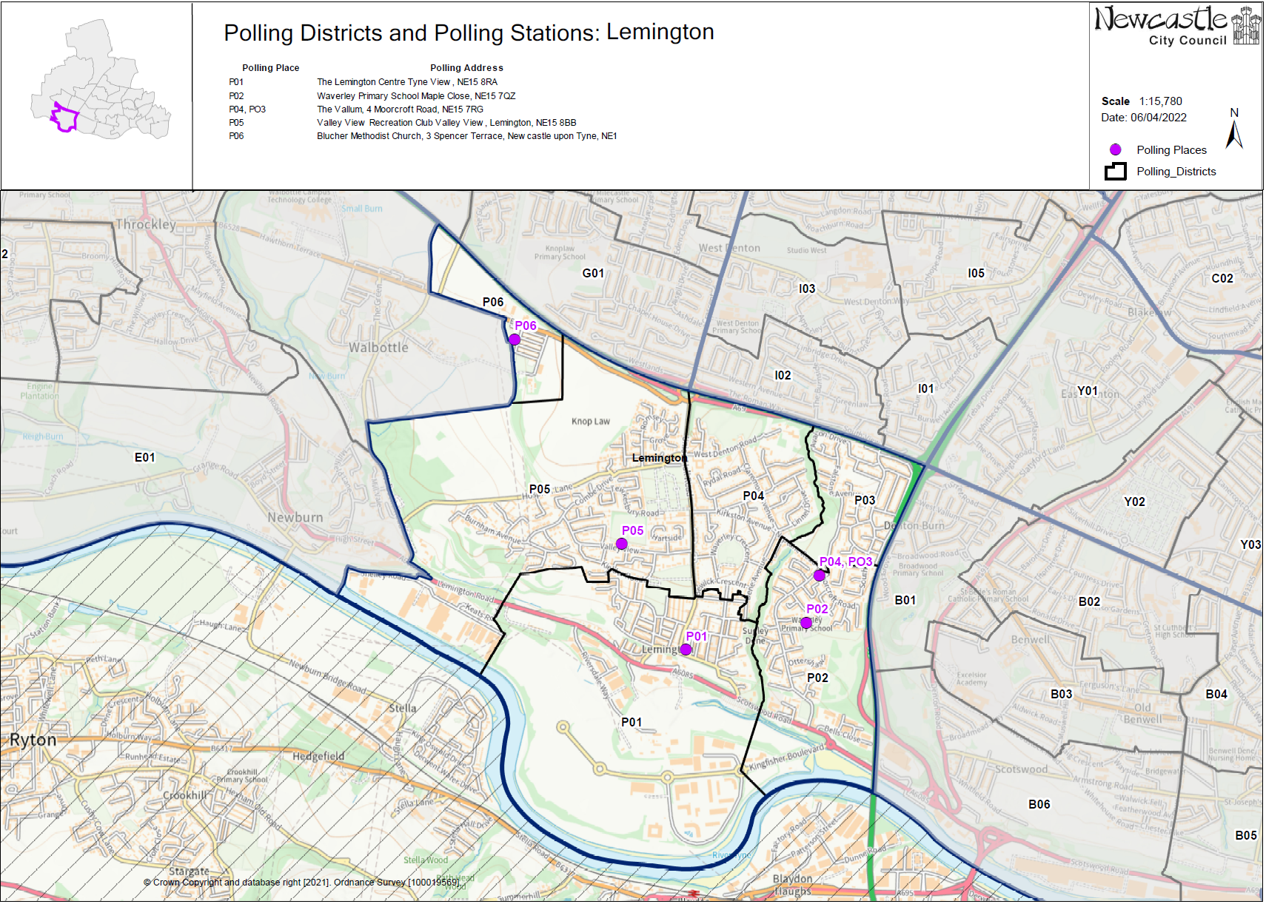

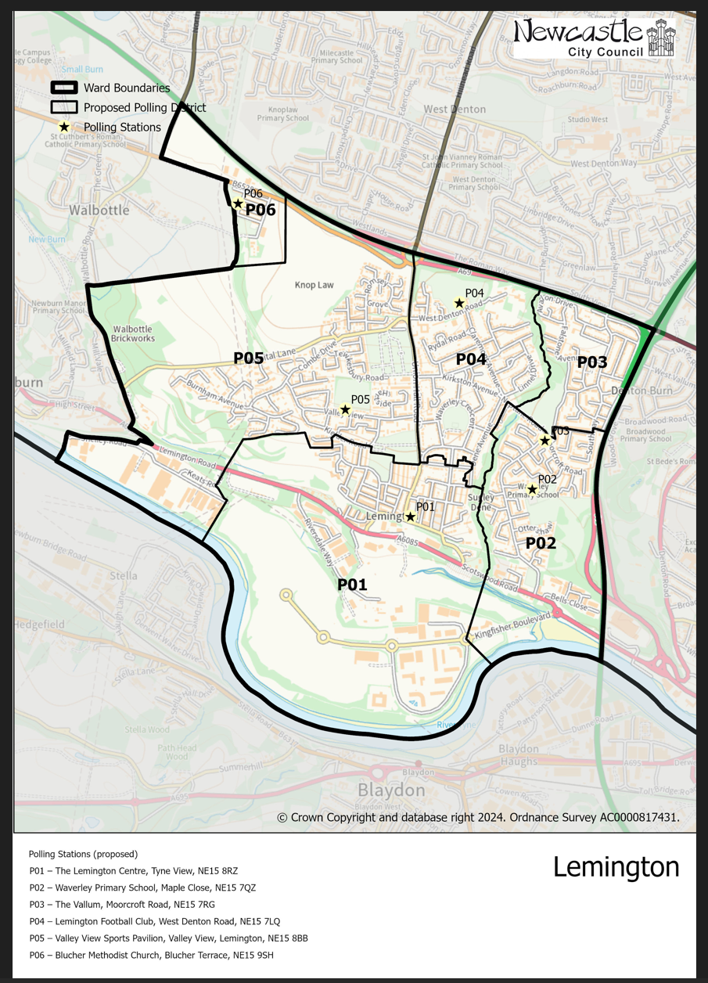**(New)**

**Lemington Ward**

This map shows the new ward and the proposed polling districts and the proposed polling places.

* **P01**

The Lemington Centre, Tyne View, NE15 8RZ

* **P02**

Waverley Primary School, Maple Close, NE15 7QZ

* **P03**

The Vallum, Moorcroft Road, NE15 7RG

* **P04**

Lemington Football Club, West Denton Road, NE15 7LQ

* **P05**

Valley View Sports Pavilion, Valley View, Lemington, NE15 8BB

* **P06**

Blucher Methodist Church, Blucher Terrace, NE15 9SH

**Lemington Ward**

**Polling District P01**

|  |  |
| --- | --- |
| **Current Polling District** | **Current Polling Place** |
| P01 (full) | The Lemington Centre, Tyne View, NE15 8RZ |

|  |  |  |
| --- | --- | --- |
| **Proposed Polling District** | **Predicted**  **Polling Station Electorate** | **Proposed Polling Place** |
| P01 | 873 | The Lemington Centre, Tyne View, NE15 8RZ |

|  |
| --- |
| **Considerations and Proposals** |
| No change to the polling district boundary.  No change to the polling place. |

|  |
| --- |
| **Preliminary Consultation – Elected Members comments and feedback** |
| No comments received. |

**Lemington Ward**

**Polling District P02**

|  |  |
| --- | --- |
| **Current Polling District** | **Current Polling Place** |
| P02 (full) | Waverley Primary School, Maple Close, NE15 7QZ |

|  |  |  |
| --- | --- | --- |
| **Proposed Polling District** | **Predicted**  **Polling Station Electorate** | **Proposed Polling Place** |
| P02 | 664 | Waverley Primary School, Maple Close, NE15 7QZ |

|  |
| --- |
| **Considerations and Proposals** |
| No changes to the polling district boundary.  No change to the polling place. |

|  |
| --- |
| **Preliminary Consultation – Elected Members comments and feedback** |
| No comments received. |

**Lemington Ward**

**Polling District P03**

|  |  |
| --- | --- |
| **Current Polling District** | **Current Polling Place** |
| P03 (full) | The Vallum, Moorcroft Road, NE15 7RG |

|  |  |  |
| --- | --- | --- |
| **Proposed Polling District** | **Predicted**  **Polling Station Electorate** | **Proposed Polling Place** |
| P03 | 541 | The Vallum, Moorcroft Road, NE15 7RG |

|  |
| --- |
| **Considerations and Proposals** |
| No changes to the polling district boundary.  No change to the polling place.    The Alan Shearer Centre was contacted, but it is unable to be used as a polling station because it is a residential centre for disabled children. |

|  |
| --- |
| **Preliminary Consultation – Elected Members comments and feedback** |
| No comments received. |

**Lemington Ward**

**Polling District P04**

|  |  |
| --- | --- |
| **Current Polling District** | **Current Polling Place** |
| P04 (full) | The Vallum, Moorcroft Road, NE15 7RG |

|  |  |  |
| --- | --- | --- |
| **Proposed Polling District** | **Predicted**  **Polling Station Electorate** | **Proposed Polling Place** |
| P04 | 827 | Lemington Football Club, West Denton Road, NE15 7LQ |

|  |
| --- |
| **Considerations and Proposals** |
| No changes to the polling district boundary.  The existing polling station is The Vallum Pub; however, it is in the current P02 polling district.  Concerns have previously been raised with regards to accessibility and location of The Vallum Pub for this district.    The Alan Shearer Centre was contacted, but it is unable to be used as a polling station because it is a residential centre for disabled children.  Lemington Football Club is the proposal. A site visit was carried out on 13 August 2025 and the building was deemed suitable to be used. |

|  |
| --- |
| **Preliminary Consultation – Elected Members comments and feedback** |
| Councillor Phillipson has expressed concerns that the location of the pub is not suitable. |

**Lemington Ward**

**Polling District P05**

|  |  |
| --- | --- |
| **Current Polling District** | **Current Polling Place** |
| P05 (full) | Valley View Sports Pavilion, Valley View, Lemington, NE15 8BB |

|  |  |  |
| --- | --- | --- |
| **Proposed Polling District** | **Predicted**  **Polling Station Electorate** | **Proposed Polling Place** |
| P05 | 1359 | Valley View Sports Pavilion, Valley View, Lemington, NE15 8BB |

|  |
| --- |
| **Considerations and Proposals** |
| No changes to the polling district boundary.  No change to the polling place. |

|  |
| --- |
| **Preliminary Consultation – Elected Members comments and feedback** |
| No comments received. |

**Lemington Ward**

**Polling District P06**

|  |  |
| --- | --- |
| **Current Polling District** | **Current Polling Place** |
| P06 (part) | Blucher Methodist Church, Blucher Terrace, NE15 9SH |

|  |  |  |
| --- | --- | --- |
| **Proposed Polling District** | **Predicted**  **Polling Station Electorate** | **Proposed Polling Place** |
| P06 | 136 | Blucher Methodist Church, Blucher Terrace, NE15 9SH |

|  |
| --- |
| **Considerations and Proposals** |
| Loses a small part of current P06 to new Throckley, Walbottle and Newburn ward.  No change to the polling place. |

|  |
| --- |
| **Preliminary Consultation – Elected Members comments and feedback** |
| No comments received. |